Southern Gospel Concert
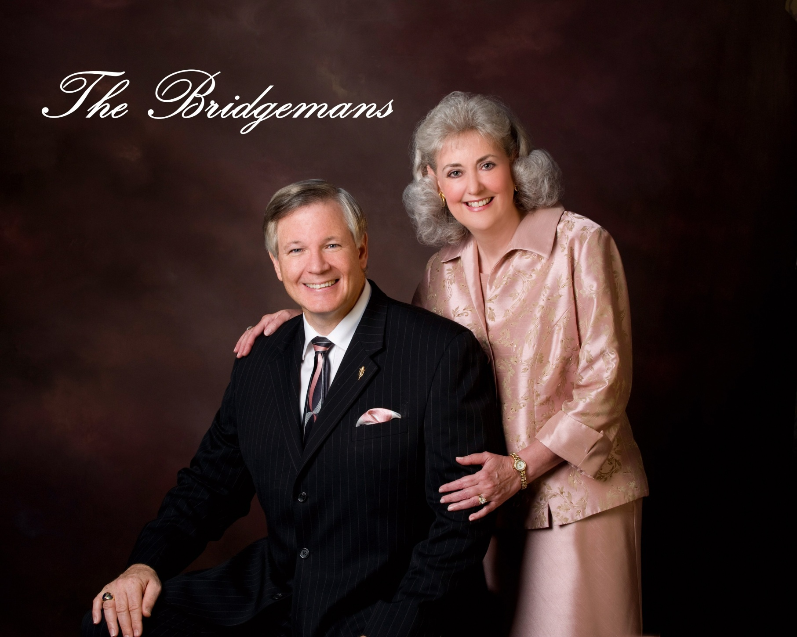
www.TheBridgemans.com

DATE: TIME:
LOCATION:

