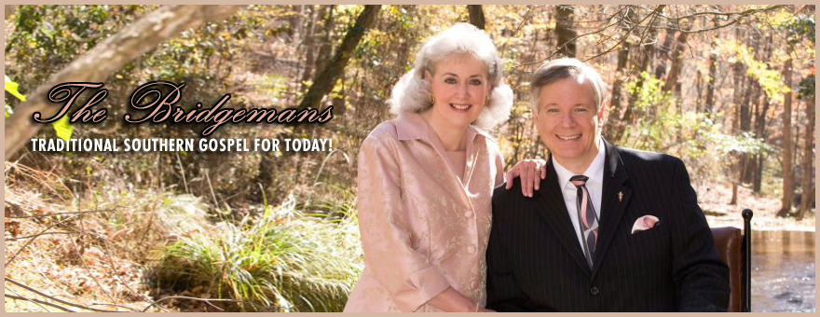​

“The Bridgemans” are Travis and Alecia Bridgeman, a husband and wife Southern Gospel duet in Cumming, Georgia. They have been singing together for over forty years. They recorded their first project, "We Will Sing Eternally" in 2002. They have a total of four CD recordings and one DVD.
Travis has served as the pastor of Antioch Baptist Church in Cumming, Georgia since 2002. He also serves on the Executive Board of the Southern Gospel Music Association in Pigeon Forge, Tennessee. He plays the keyboard on several of their projects. His life verse is Philippians 1:6 "Being confident of this very thing, that he which hath begun a good work in you will perform it until the day of Jesus Christ:"
Alecia has written two songs for their project, “We Can Hardly Wait!”. As a pastor’s wife and mother, she is also active in their church women’s ministries and play the flute. Her life verse is Philippians 4:8, “Finally, brethren, whatsoever things are true, whatsoever things are honest, whatsoever things are just, whatsoever things are pure, whatsoever things are lovely, whatsoever things are of good report; if there be any virtue, and if there be any praise, think on these things.”
God has opened many doors for them, including on radio and television. They were named in the top five of favorite Southern Gospel artists in the Atlanta, Georgia for the four years, and "Top Duet" from 2010 to 2015 by "The Light Atlanta". And in 2012, they were named "Duet of the Year" by the "Southeastern Southern Gospel Music Conference" in Valdosta, Georgia.
They have sung on the National Quartet Convention showcase and will be singing at the Ark Encounter in Kentucky next month.
They have one son, Lee, who is featured on keyboard solos on their projects. They enjoy singing at revivals, festivals, senior meetings and any door the Lord opens for them. Together they claim Ephesians 5:19 for their ministry, “Speaking to yourselves in psalms and hymns and spiritual songs, singing and making melody in your heart to the Lord;”

